LAB 2 WORKSHEET

**Title: UART Driver**

**Name: Chinyere Gloria Mbaka**

**Date Performed: January 24 & 26 2024**

**Course Name: CMPE 460 - Interface & Digital Electronic**

**TA’s Name: Colin**

**Instructor’s Name: Professor Ketout Hussin**

**Results**

The screenshots of the result for part 1 and part 2 are shown in Figure 1 and 2 respectively.

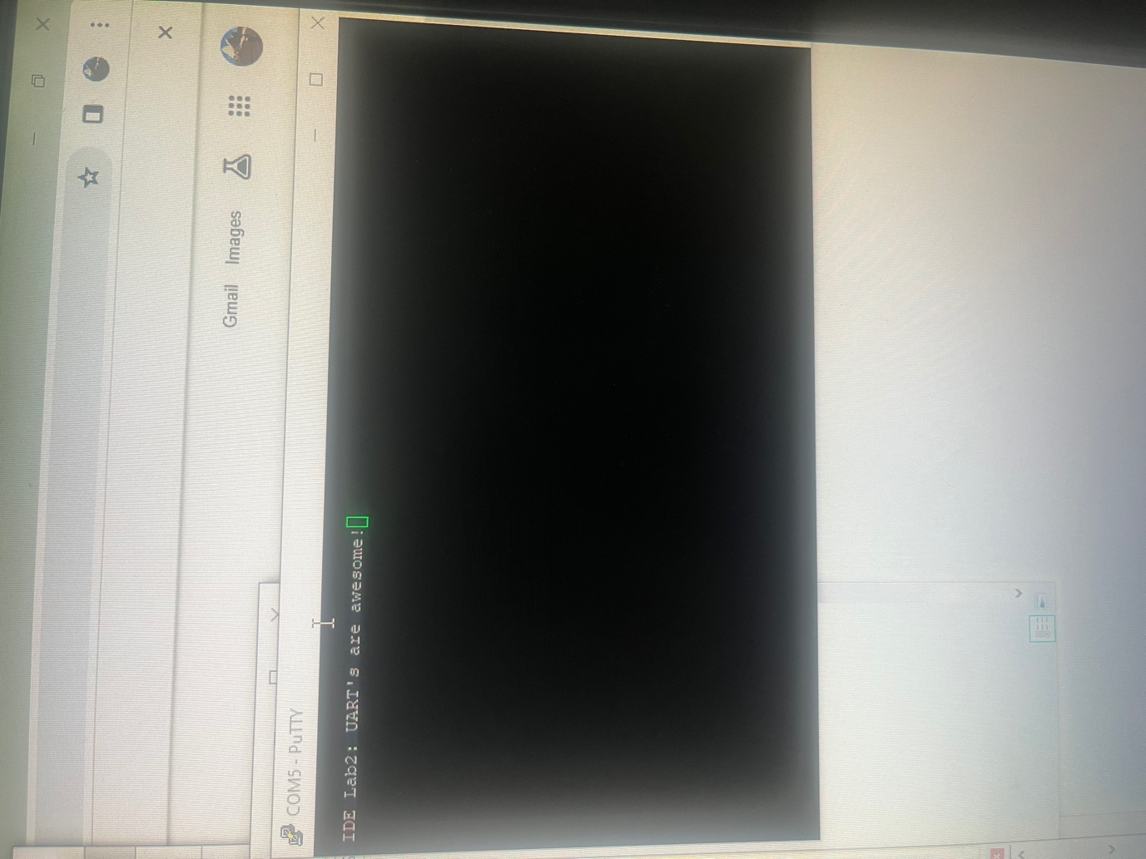

Figure 1: Screenshot of the terminal from part 1

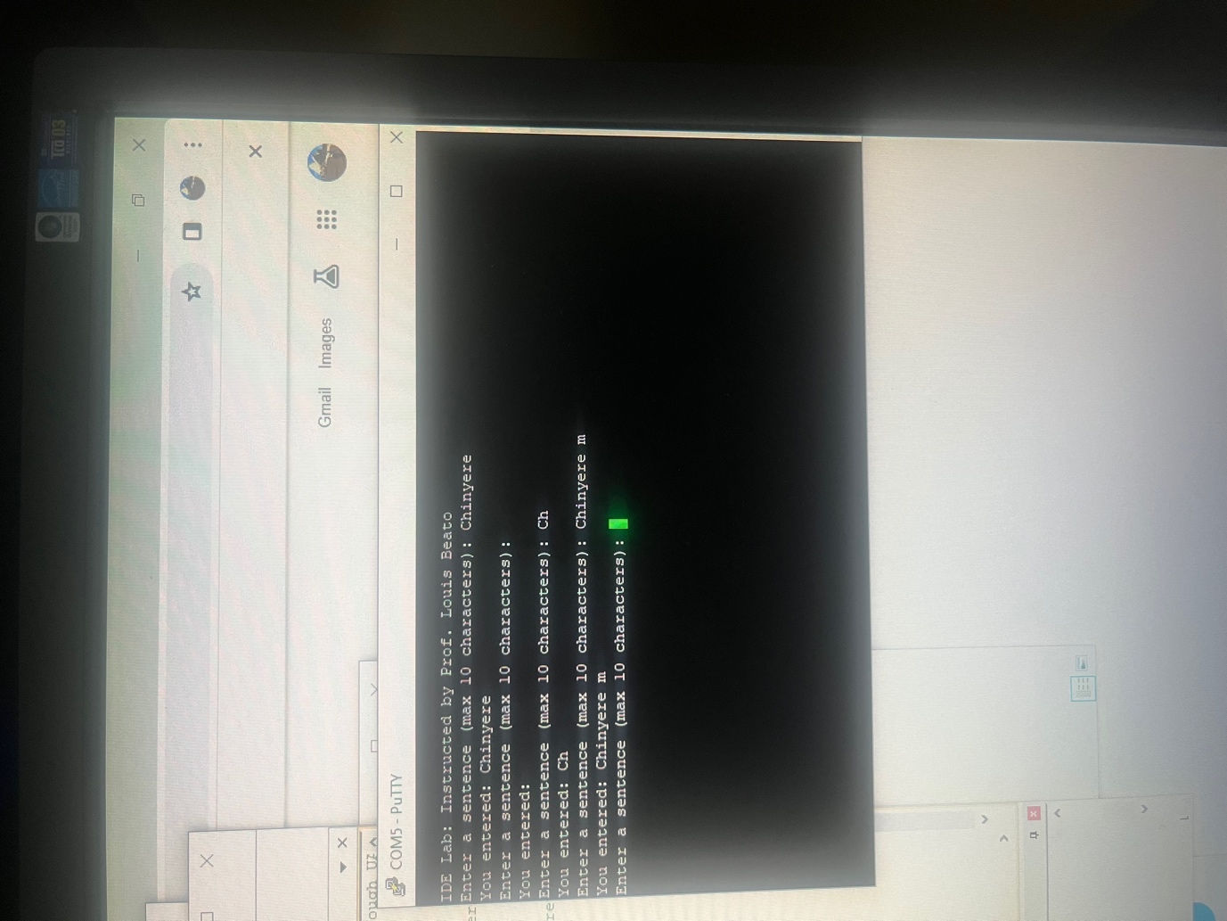

Figure 2: Screenshot of the terminal from part 2

**Sign-off Sheet**

